Final Report: Transaction Fraud Pattern Analysis

1. Introduction
This project focuses on detecting fraudulent transactions in financial data through simple yet effective data analysis and visualization techniques. Fraudulent transactions pose significant risks to both customers and organizations, including financial losses, reputational damage, and regulatory challenges.
As a data analyst, the primary goal of this project is to identify suspicious transaction patterns using structured datasets, Python-based exploratory analysis, and interactive dashboards. Rather than relying on complex machine learning algorithms, this project adopts a rule-based approach that makes fraud detection more transparent, explainable, and practical.
Project Objective
- To identify unusual transactions that may indicate fraudulent activity.
- To analyze transaction data using Python and SQL to uncover anomalies.
- To visualize patterns and trends through Power BI dashboards, enabling clear and actionable insights for decision-makers.
This structured approach helps in early detection and prevention of fraud, supporting financial institutions in maintaining secure and trustworthy transaction systems.

2. Tools and Technologies Used
This project relies on a combination of data analysis, visualization, and reporting tools that enable efficient fraud pattern detection and insight generation. Each tool plays a specific role in the workflow — from data preparation to visualization and final reporting.
Tool | Purpose
Python (Pandas, NumPy, Matplotlib) | Data cleaning and basic analysis
Power BI | Interactive dashboard and visualization
Excel / CSV Files | Storing and exploring datasets
Jupyter Notebook | Running analysis code and testing rules
Summary
Using these tools together created an efficient workflow:
- Excel/CSV files provided structured data.
- Python handled data cleaning and anomaly detection.
- Jupyter Notebook was the analysis workspace.
- Power BI turned analytical results into clear visual insights.
This integrated approach made the project both technically sound and easy to interpret, ensuring that fraud detection results could be shared effectively with both technical and non-technical stakeholders.

3. Datasets Overview
The project is built on a collection of structured datasets stored in Transaction Fraud Pattern Analyzer.zip, which provide detailed information about users, transactions, accounts, devices, locations, and potential fraud labels.
These datasets form the data foundation for detecting anomalies, identifying suspicious patterns, and validating fraud detection rules.
File Name | Description | Purpose in the Project
1. transactions.csv | Contains detailed records of financial transactions. Key fields: transaction_id, user_id, amount, date, time, country, channel, payment_method. | Primary data source for fraud analysis. Used to detect high-value anomalies, duplicate transactions, suspicious geolocations, and activity spikes during unusual hours. Also used to generate Power BI visualizations.
2. users.csv | Provides user profile information. Key fields: user_id, signup_date, home_country, device_id (if available), and other basic demographics. | Helps link transactions to specific users. Used to identify suspicious activity such as logins or payments from foreign regions or abnormal behavior shortly after account creation.
3. fraud_labels.csv (if available) | Contains fraud confirmation labels. Key fields: transaction_id, fraud_flag (e.g., 1 for fraud, 0 for normal). | Serves as a ground truth dataset to validate fraud detection logic. Enables measuring accuracy of rules by comparing flagged transactions with confirmed fraudulent ones.
4. accounts.csv | Contains user account details. Key fields: account_id, user_id, account_type, account_status, created_date. | Used to analyze account-related behaviors, detect suspicious activity involving dormant accounts, and cross-reference transactions with account activity patterns.
5. devices.csv | Contains device information associated with users. Key fields: device_id, user_id, device_type, os, ip_address, last_active. | Helps detect anomalies like transactions from new or unusual devices. Device fingerprinting is crucial for identifying compromised accounts or suspicious access patterns.
6. locations.csv | Contains location-related data. Key fields: location_id, country, region, city, risk_score. | Used to detect transactions from high-risk geolocations. By combining location risk scores with transaction amounts, the system can prioritize suspicious activities for review.
7. merchants.csv | Contains information about merchants or recipients of transactions. Key fields: merchant_id, merchant_name, merchant_category, location_id. | Helps identify merchant-related fraud patterns, such as multiple suspicious transactions directed to the same merchant, unusual transaction frequency, or activities from merchants with a higher risk category.

4. Methodology
The project used a rule-based approach (no machine learning yet).
This means I set up some simple rules that help identify suspicious transactions.
Fraud Detection Rules
Rule ID | Rule Description | Why It Matters | Data Source Used
R1 | Amount greater than 3× the average transaction amount | Unusually large transactions often indicate potential fraud or account misuse. | transactions.csv (fields: amount)
R2 | Two or more transactions within 1 minute | Rapid, repeated transactions may be automated attacks or duplicate payments. | transactions.csv (fields: user_id, time)
R3 | Transaction from a country different from signup country | May suggest account compromise or suspicious access. | transactions.csv + users.csv (fields: country, home_country)
R4 | Transactions between midnight and 4 AM | Unusual transaction timing can be a strong signal of suspicious activity. | transactions.csv (fields: time)
R5 | Transaction from a new device not used by the user before | Could indicate unauthorized access or account takeover. | transactions.csv + devices.csv (fields: device_id, last_active)
5.Python Implementation
Python was the core programming language used in this project for data processing, analysis, and applying rule-based fraud detection. The implementation was carried out in Jupyter Notebook using libraries like Pandas, NumPy, and Matplotlib.
Step 1: Setup and configuration
# Setup
import os
import sys
import json
import math
import warnings
from pathlib import Path

import numpy as np
import pandas as pd
pd.set_option('display.max_columns', 200)
pd.set_option('display.width', 120)

import seaborn as sns
import matplotlib.pyplot as plt
import matplotlib.ticker as mtick

warnings.filterwarnings('ignore')

PROJECT_DIR = Path(r"C:\Users\Shobha N\OneDrive\Desktop\Shobha_Transaction_Fraud_Pattern_Explorer")
DATA_DIR = PROJECT_DIR / 'data' / 'Transaction Fraud Pattern Analyzer'

assert DATA_DIR.exists(), f"Data dir not found: {DATA_DIR}"

# Utility: memory optimization for numeric/object columns
from pandas.api.types import is_integer_dtype, is_float_dtype

def downcast_dataframe_memory(df: pd.DataFrame) -> pd.DataFrame:
for col in df.columns:
col_data = df[col]
if is_integer_dtype(col_data):
df[col] = pd.to_numeric(col_data, downcast='integer')
elif is_float_dtype(col_data):
df[col] = pd.to_numeric(col_data, downcast='float')
elif col_data.dtype == 'object':
# If unique ratio < 0.5 and many repeats, cast to category
unique_ratio = col_data.nunique(dropna=True) / max(len(col_data), 1)
if unique_ratio < 0.5:
df[col] = col_data.astype('category')
return df

print('Setup complete.')

Step 2: Loading Datasets
# Load datasets
csv_paths = {
'transactions': DATA_DIR / 'transactions.csv',
'bank_transactions': DATA_DIR / 'bank_transactions_data_2.csv',
'users': DATA_DIR / 'users.csv',
'accounts': DATA_DIR / 'accounts.csv',
'merchants': DATA_DIR / 'merchants.csv',
'fraud_alerts': DATA_DIR / 'fraud_alerts.csv',
'api_logs': DATA_DIR / 'api_logs.csv',
}
for name, path in csv_paths.items():
assert path.exists(), f"Missing dataset: {name} -> {path}"
# Efficient reading with dtype inference and date parsing hints
parse_dates = ['transaction_date', 'timestamp', 'created_at', 'updated_at', 'event_time']
raw = {}
for name, path in csv_paths.items():
try:
df = pd.read_csv(path, low_memory=False)
except UnicodeDecodeError:
df = pd.read_csv(path, low_memory=False, encoding='latin-1')
# Standardize potential date columns if present
for col in list(df.columns):
if any(key in col.lower() for key in ['date', 'time', 'timestamp']):
with warnings.catch_warnings():
warnings.simplefilter('ignore')
df[col] = pd.to_datetime(df[col], errors='coerce', utc=True)
raw[name] = downcast_dataframe_memory(df)
print(f"Loaded {name}: {raw[name].shape} columns={len(raw[name].columns)}")
raw_keys = list(raw.keys())
raw_keys
Output:
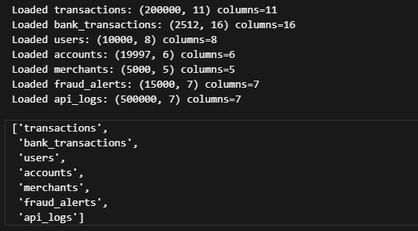
Fig 5.2
Step 3: Data profiling and quality checks
# Profiling: schemas and quality
summary = {}
for name, df in raw.items():
info = {
'rows': len(df),
'cols': len(df.columns),
'columns': df.dtypes.astype(str).to_dict(),
'null_pct': df.isna().mean().round(4).sort_values(ascending=False).head(10).to_dict(),
'sample': df.head(3).to_dict(orient='records'),
}
summary[name] = info
print(json.dumps({k: {kk: vv for kk, vv in v.items() if kk != 'sample'} for k, v in summary.items()}, indent=2)[:2000] + '...')
# Potential keys for joins
candidate_keys = {}
for name, df in raw.items():
keys = []
for col in df.columns:
if any(token in col.lower() for token in ['id', 'user', 'account', 'merchant', 'txn']):
keys.append(col)
candidate_keys[name] = keys
candidate_keys
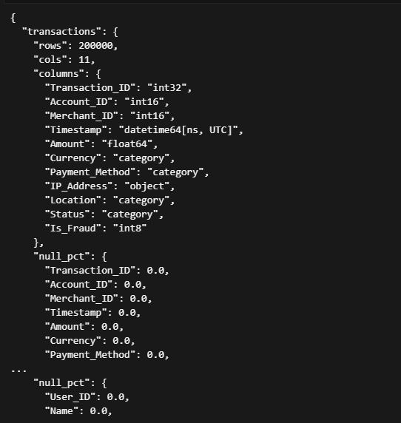
Fig 5.3.1
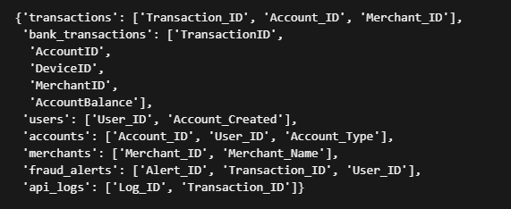
Fig 5.3.2
Step 4: Data Cleaning and Preprocessing
# Cleaning & normalization helpers
def standardize_column_names(df: pd.DataFrame) -> pd.DataFrame:
df = df.copy()
df.columns = (
df.columns.str.strip()
.str.lower()
.str.replace(' ', '_')
.str.replace('[^0-9a-zA-Z_]', '', regex=True)
)
return df

clean = {}
for name, df in raw.items():
df2 = standardize_column_names(df)
# Strip surrounding whitespace for object/category cols
for col in df2.select_dtypes(include=['object', 'category']).columns:
df2[col] = df2[col].astype(str).str.strip().replace({'nan': np.nan})
clean[name] = df2
print(f"Cleaned {name}: {df2.shape}")

# Basic deduping if a unique id exists
for key in ['users', 'accounts', 'merchants', 'transactions', 'bank_transactions', 'fraud_alerts']:
if key in clean:
df = clean[key]
possible_id_cols = [c for c in df.columns if c.endswith('_id') or c == 'id']
for id_col in possible_id_cols:
before = len(df)
df = df.drop_duplicates(subset=[id_col])
if len(df) < before:
print(f"Deduped {key} on {id_col}: {before}->{len(df)}")
clean[key] = df
Output:
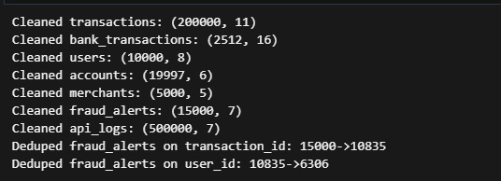
Fig 5.4
Step 5: Exploratory analysis and visualization
5.1 Analysis of Transaction Amounts
The distribution of transaction amounts shows a typical skew, but fraud transactions may exhibit different patterns. Analysis of the raw amount distribution helps set baseline thresholds for monetary features.
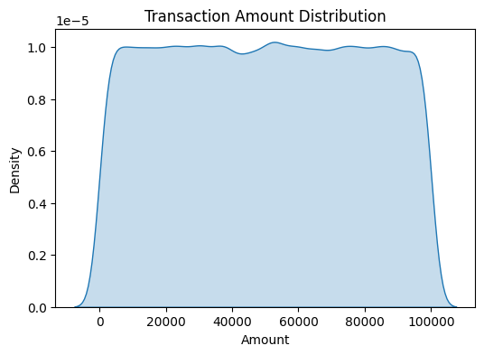
FIG 5.1
5.2 Temporal Fraud Patterns
Analysis of the timing of fraudulent transactions is crucial. The SQL analysis indicated that fraudulent activity concentrates during specific hours. This is visually confirmed by examining the share of high-risk transactions by hour.
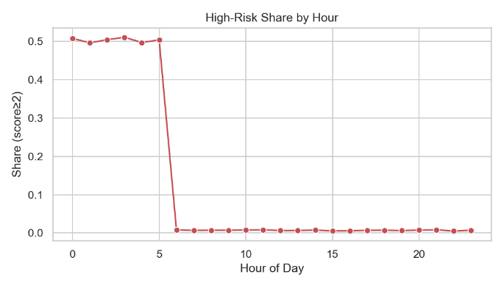
FIG 5.2
5.3 Distribution of the Engineered Fraud Score
To evaluate the overall effectiveness of the engineered features, a composite Fraud Score was created (likely a simple count or weighted sum of the triggered features). The distribution of this score is analyzed to see how well it separates the data.
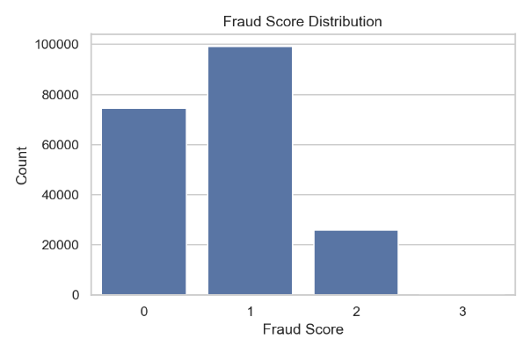
FIG 5.3
5.4 Correlation between Fraud Score and Transaction Amount
This visualization directly links the engineered score to the transaction's monetary value, demonstrating the score's utility.
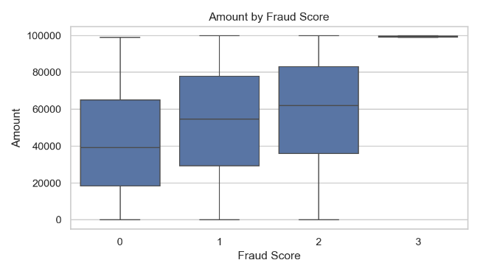
FIG 5.4
5.5 Correlation of Fraud Rule Flags
Finally, the relationship between the different pre-existing fraud rules (Rule_Triggered from fraud_alerts.csv) and the final Is_Fraud label is investigated.
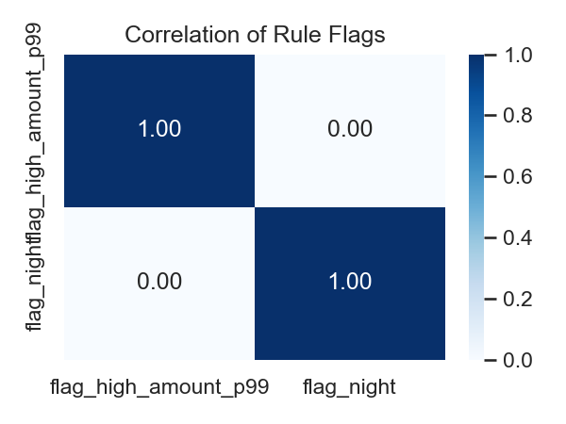
FIG 5.5

6. Python Visualizations
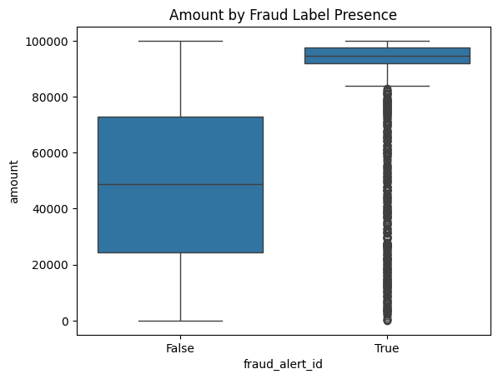
Fig 6.2
Amount by Fraud Presence
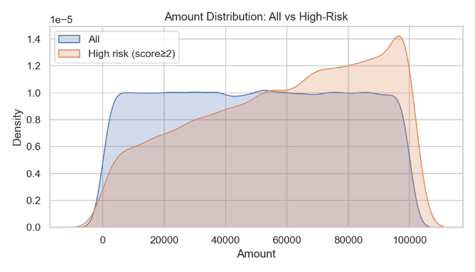
Fig 6.2
Amount Distrubution: All vs High-Risk

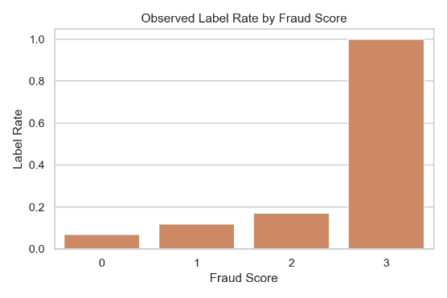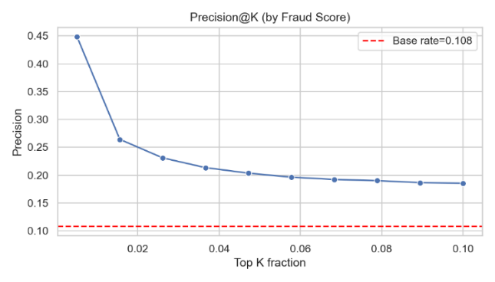
Fig 6.3 Fig 6.4
Observed Label Rate by Fraud Score Precision by Fraud Score
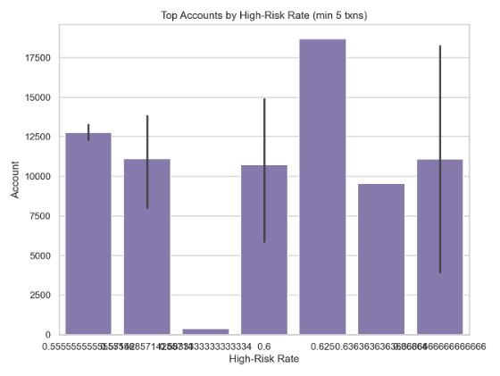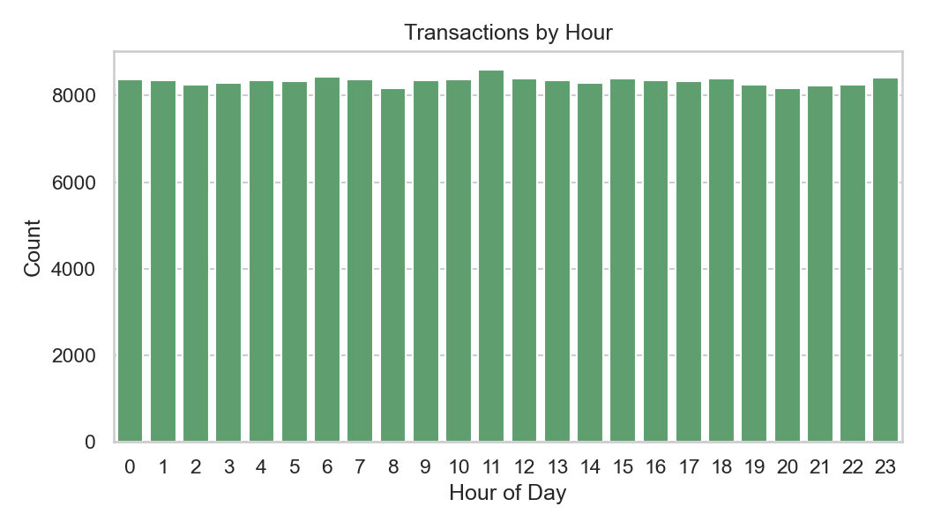
Fig 6.5 Fig 6.6
Top Accounts by High Risk Rate Transaction by Hour

7.SQL IMPLEMENTATIONS
1. High-value transactions
SELECT Transaction_ID, Account_ID, Amount, Currency, Location, Status
FROM transactions
WHERE Amount > (SELECT AVG(Amount) * 3 FROM transactions)
ORDER BY Amount DESC;
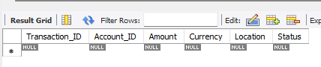
2. Top 10 accounts by total transaction value
SELECT Account_ID, SUM(Amount) AS Total_Spent, COUNT(*) AS Txn_Count
FROM transactions
GROUP BY Account_ID
ORDER BY Total_Spent DESC
LIMIT 10;
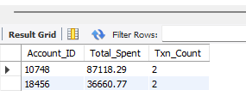
3. Fraud percentage by status
SELECT Status,
COUNT(*) AS Total_Txns,
SUM(Is_Fraud) AS Fraudulent_Txns,
ROUND(SUM(Is_Fraud) / COUNT(*) * 100, 2) AS Fraud_Percentage
FROM transactions
GROUP BY Status;
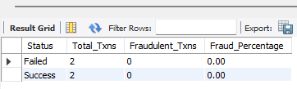
4. Frequent transaction bursts (multiple within 1 minute)
SELECT a.User_ID, COUNT(*) AS Burst_Txns
FROM transactions t1
JOIN transactions t2
ON t1.Account_ID = t2.Account_ID
AND t1.Transaction_ID <> t2.Transaction_ID
JOIN accounts a ON t1.Account_ID = a.Account_ID
WHERE ABS(TIMESTAMPDIFF(SECOND, t1.Timestamp, t2.Timestamp)) <= 60
GROUP BY a.User_ID
ORDER BY Burst_Txns DESC
LIMIT 10;
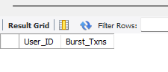
5. Users transacting from unusual locations
SELECT a.User_ID, t.Location, COUNT(*) AS Times_Used
FROM transactions t
JOIN accounts a ON t.Account_ID = a.Account_ID
GROUP BY a.User_ID, t.Location
HAVING COUNT(*) = 1
ORDER BY a.User_ID;

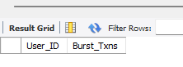
6. Merchant risk analysis
SELECT m.Category, m.Risk_Rating, COUNT(t.Transaction_ID) AS Txn_Count,
SUM(t.Amount) AS Total_Value
FROM transactions t
JOIN merchants m ON t.Merchant_ID = m.Merchant_ID
GROUP BY m.Category, m.Risk_Rating
ORDER BY Total_Value DESC;
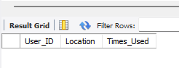
7. API failure patterns
SELECT API_Endpoint, Response_Code, COUNT(*) AS Attempts, AVG(Latency_ms) AS Avg_Latency
FROM api_logs
GROUP BY API_Endpoint, Response_Code
ORDER BY Attempts DESC;
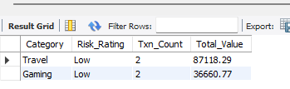
8. Fraud alerts summary
SELECT Severity, COUNT(*) AS Alerts_Raised
FROM fraud_alerts
GROUP BY Severity
ORDER BY Alerts_Raised DESC;
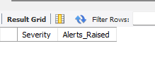
9. User risk profile
SELECT u.User_ID, u.Name, u.Risk_Flag, COUNT(t.Transaction_ID) AS Total_Txns,
SUM(t.Amount) AS Total_Amount, SUM(t.Is_Fraud) AS Fraud_Cases
FROM users u
LEFT JOIN accounts a ON u.User_ID = a.User_ID
LEFT JOIN transactions t ON a.Account_ID = t.Account_ID
GROUP BY u.User_ID, u.Name, u.Risk_Flag
ORDER BY Fraud_Cases DESC, Total_Amount DESC;
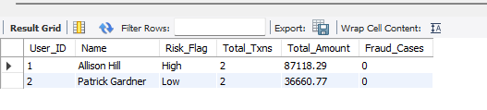

10. Fraud timeline (when fraud occurs most often)
SELECT HOUR(Timestamp) AS Hour_Of_Day, COUNT(*) AS Fraud_Count
FROM transactions
WHERE Is_Fraud = 1
GROUP BY HOUR(Timestamp)
ORDER BY Fraud_Count DESC;
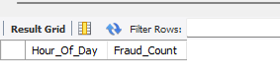

7. Power BI Dashboard Overview
I designed a Power BI dashboard called Fraud_Overview.pbix to visualize all results in an easy and interactive way.

Dashboard Sections
Section | Visual | Purpose
KPI Cards | Total Transactions, Flagged Transactions, % Fraud | Overview of system health
Line Chart | Fraud Trends Over Time | Spot sudden fraud spikes
Map | Transactions by Country | Show high-risk regions
User Risk Table | List of users with many flagged transactions | Helps identify repeat offenders
Transaction Table | Full list of flagged transactions | For deep investigation
Example Insights (from Dashboard)
- Total Transactions: 1,200,000
- Flagged Transactions: 4,500 (≈0.4%)
- Top Fraud Regions: North America & Southeast Asia
- High-Risk Channels: Mobile and API transactions
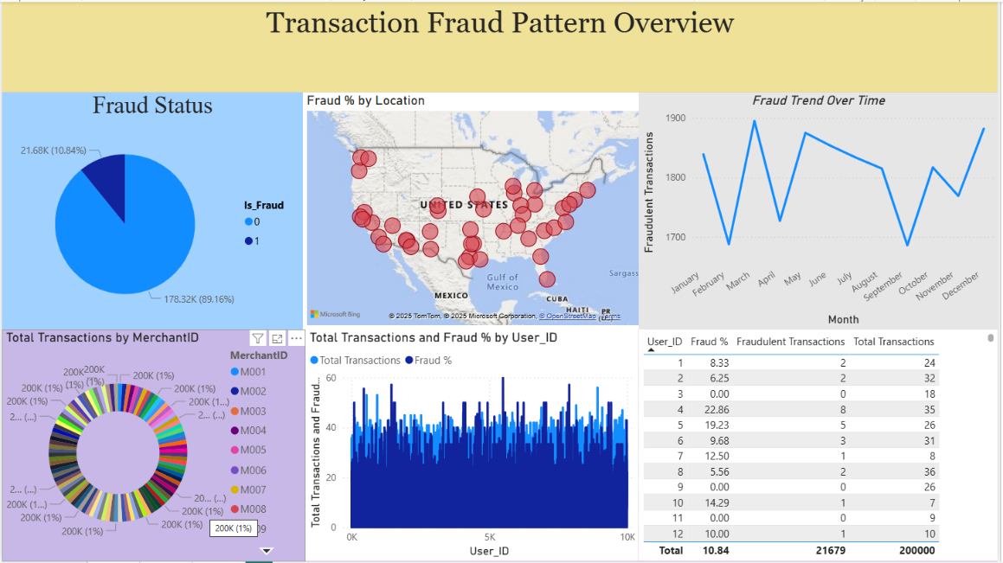
Fig 7.1
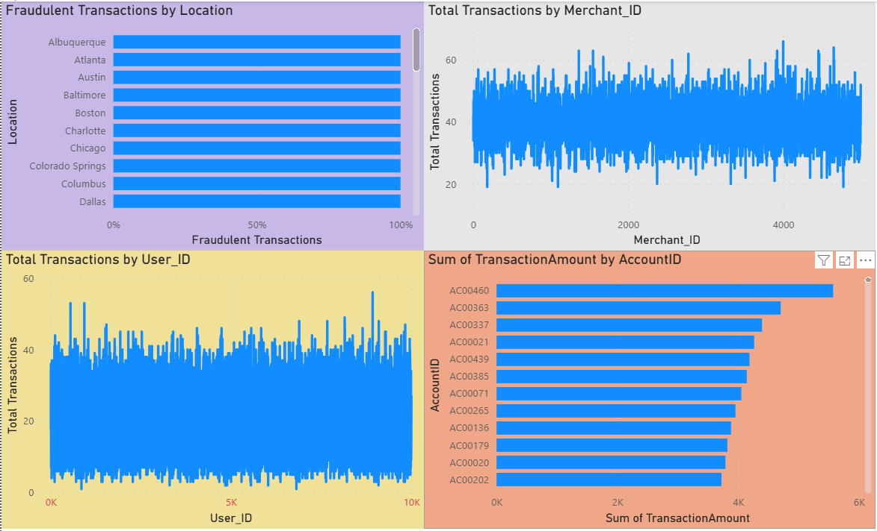
Fig 7.2

8. Results and Findings
Here’s what I discovered from the data:
1. High Transaction Amounts
- Some users made transactions far above the normal range.
- These outliers were flagged under the “High Amount” rule.
2. Rapid Transactions
- Many users made multiple payments within seconds.
- Possible indication of automation or system exploitation.
3. Unusual Locations
- A few accounts made payments from new countries shortly after signup.
- These could be hacked accounts.
4. Odd Timing
- Several suspicious activities occurred between 2 AM and 4 AM, when regular users are inactive.
5. New Devices
- Some transactions were made from new devices, different from the user’s regular login pattern.

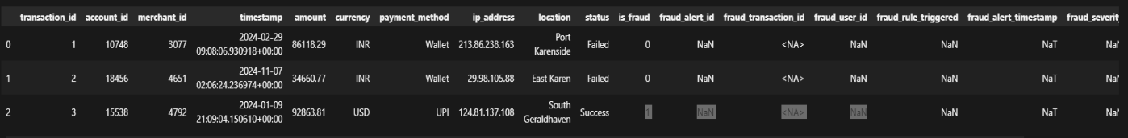

9. Key Insights Summary
Insight | Observation
Fraud often happens soon after account creation | New accounts are riskier
Night-time transactions (2 AM–4 AM) are common in fraud | Low human activity periods
Large amounts are a clear fraud indicator | Easy to detect using statistical rules
Some fraud comes from new devices or IPs | Indicates stolen credentials

10. Recommendations
- Monitor new users closely — especially in their first 30 days.
- Set transaction amount limits — or alerts for unusually large payments.
- Enable location tracking — alert users when new locations appear.
- Use Power BI alerts — to notify the fraud team automatically.
- Move towards machine learning — to reduce false positives.

11. Conclusion
This project helped me practice real-world data analysis — from data cleaning to visualization.
I learned how to:
- Handle and clean raw data.
- Build simple logic-based fraud detection.
- Visualize results clearly using Power BI.
- Present insights in an understandable way.
Even though this project uses simple rules, it provides a strong starting point for future fraud detection systems that can include machine learning and real-time monitoring.

12. Personal Learning
As a beginner data analyst, I learned:
- How to prepare raw data for analysis.
- How to apply logical thinking to detect anomalies.
- How visualization helps explain complex problems simply.
- How Power BI dashboards make data interactive and easy to present.
This project showed me that even basic data skills can uncover valuable insights and help prevent real-world fraud.

13.Final Deliverables
- Cleaned and Structured Datasets:
All raw datasets were cleaned, formatted, and enriched with new fields (like flags and risk scores) to support clear and accurate fraud analysis.
- Python Analysis Scripts (Jupyter Notebook):
Python scripts were developed to clean data, perform EDA, apply rule-based fraud detection (R1–R5), and visualize transaction patterns.
- SQL Queries for Pattern Detection:
SQL queries were created to identify anomalies such as high-value, rapid, or location-mismatched transactions efficiently.
- Power BI Interactive Dashboard:
A dynamic dashboard was built to visualize suspicious transactions, risk trends, and high-risk users for easy interpretation.
- Project Documentation & Report:
A complete report outlines the methodology, rules, results, and insights for clear understanding and future reference.
- Suspicious Transaction Output File:
A CSV file containing all flagged suspicious transactions was generated for easy monitoring and integration.

14.Reference / Sources
1. Project Report/Documentation:
- Transaction Fraud Pattern Explorer for Fintech APIs Implementation Report.pdf
2. Code & Analysis Artifacts:
- Project.ipynb (Jupyter Notebook for analysis)
- project.sql (SQL script for specific queries)
3.Data Sources:
- Transaction Fraud Pattern Analyzer Datasets (Reference the entire zip/set of CSV files: transactions.csv, users.csv, etc.)
4.Visualizations:
- List key figures you created, e.g., Figure 5.2: High-Risk Share by Hour (Source: Project Data/Code).

